P2 Final Report – Emergency Fall Detection Device

APSC 200/293

Electrical and Computer Engineering

Section 208

Team 12C

TA: Campbell Thom

Akshay Thakore, Alexander McKinney, Matthew Mamelak, Robbie Mallette, Sam Lee

December 5rd, 2021

# Statement of Originality

Our signatures below attest that this submission is our original work.

Following professional engineering practice, we bear the burden of proof for original work. Therefore, we have read the Policy on Academic Integrity posted on the Faculty of Engineering and Applied Science website (<http://engineering.queensu.ca/policy/Honesty.html>) and confirm that this work is in accordance with the Policy.

**Individual 1:**

|  |  |  |  |
| --- | --- | --- | --- |
| Signature: | Akshay Thakore | Date: | December 5th, 2021 |
| Name: | Akshay Thakore | ID #: | 20228443 |

**Individual 2:**

|  |  |  |  |
| --- | --- | --- | --- |
| Signature: | Alexander McKinney | Date: | December 5th, 2021 |
| Name: | Alexander McKinney | ID #: | 20203033 |

**Individual 3:**

|  |  |  |  |
| --- | --- | --- | --- |
| Signature: | Matthew Mamelak | Date: | December 5th, 2021 |
| Name: | Matthew Mamelak | ID #: | 20216737 |

**Individual 4:**

|  |  |  |  |
| --- | --- | --- | --- |
| Signature: | Robbie Mallette | Date: | December 5th, 2021 |
| Name: | Robbie Mallette | ID #: | 20231361 |

**Individual 5:**

|  |  |  |  |
| --- | --- | --- | --- |
| Signature: | Sam Lee | Date: | December 5th, 2021 |
| Name: | Sam Lee | ID #: | 20212006 |

|  |  |  |  |
| --- | --- | --- | --- |
|  | **Content**  Identify here the sections of the report for which you contributed content. | **Write-up**  Identify the sections of the report that you wrote or edited. | **Editing** Identify the sections of the report that you edited. |
| Akshay Thakore | Problem statement, stakeholders, design criteria | All | All |
| Alexander McKinney | Executive summary, Discussion, Conclusion, Recommendations | Executive summary, Discussion, Conclusion, Recommendations | All |
| Matthew Mamelak | Executive summary, Problem statement, Functional, and design specification | All | All |
| Robbie Mallette | Background Information/Research, Project Plan, Stakeholders | Background Information/Research, Project Plan | All Parts |
| Sam Lee | Design criteria | Design criteria | Design criteria |

# Executive Summary

The purpose of the Emergency Fall Detection Device (EFDD) is to help provide immediate assistance to those who are immobilized due to a fall. Especially for the elderly, falling to the ground can lead to dangerous and life-threatening injuries, the seriousness of which depends on the response time of medical responders. The EFDD can assist the user by requesting emergency assistance within 20 seconds of the fall, even if the user is unresponsive. Powered by a 9V battery, the device consists of an accelerometer, an Arduino UNO R3 controller, a Bluetooth module, an LCD display, a buzzer, and 2 buttons.

The primary stakeholders that were considered were the elderly as well as those who are physically disabled. Both of these groups sometimes need supervision or assistance when walking or performing some type of exercise. The purpose of the Emergency Fall Detection Device is to allow those individuals to be left unsupervised, but still have assistance by their side if they are in danger or injure themselves. Another important stakeholder is the caretaker or loved one who will be contacted in case of an emergency fall. These people are putting full trust in this device to ensure the user’s safety. Therefore, it is essential that this device performs up to its expectations and handles all areas of possible error. Other key stakeholders that must be considered are the manufacturers of the device’s components, as each component of the design must function properly. People are purchasing this device knowing that it will save somebody’s life, so it is essential that each component is functional and responsive.

The 9V battery is required to supply power to the Arduino board for it to function wirelessly. The device does not require a large source of power to operate, therefore the device can last for many days before recharging or replacing the batteries. The accelerometer sensor is used to measure the acceleration of the person falling by analyzing data in 3 axes. This data is then sent and processed by the Arduino controller, which indicates the event of a fall when the accelerometer data exceeds a predefined threshold. The Bluetooth module helps share data between devices. The Bluetooth module will receive results from the Arduino controller, and it will then communicate with external devices that were paired with the device during the setup process of the emergency device. The liquid-crystal display (LCD) screen will communicate with the user to help determine whether he or she is okay. The LCD screen chosen for this device will be compatible with the Arduino R3 controller, and it will also be energy efficient so that it does not drain all the power from the 9V battery.

To allow the target market to afford this device it must be priced appropriately. The prototype, or each individual component of the design, costs a total of $61.62. The device is planning to be sold for $79.99. Setting the price of the EFDD will make this product affordable, and it will also return great profit margins. The Arduino board is $20, the multiple components such as the accelerometer, LCD screen, and Bluetooth module costs $35. The remaining $5 is allocated to the case that will house all the components and a battery so that the device can be portable. Selling the device at $79.99 returns 29.82%% profit, which can be used to maintain the product and all the required services, and it allows for research and development of newer products that can better help individuals.

Table of Contents

Statement of Originality ii

Executive Summary i

List of Figures iii

List of Tables iii

Introduction and Problem Definition 1

Background Information 1

Problem Statement 2

Stakeholder Information 2

Discussion 3

Design Criteria and Hardware Information 3

Functional and Performance Specifications 5

Idea Generation 6

Design Concept Selection 7

Development of Final Design 8

Circuit Schematic 8

Sensor Calibration and Programming 9

Prototype 10

Assessment against Project Metrics 13

Environmental and Social Considerations 13

Economic Considerations 14

Professionalism, Safety, Regulatory Compliances and Ethics 15

Conclusions 16

Recommendations 16

List of References 18

# List of Figures

Figure 1: Block Diagram of EFDD 5

Figure 2: Flowchart used to organize code structure. 6

Figure 3: Circuit schematic of the device prototype 8

Figure 4: Triaxial readings from the accelerometer when it is held in various positions 9

Figure 5: Acceleration change computation pseudocode 10

Figure 6: Accelerometer data after code modification 10

Figure 7: The completed physical prototype 11

Figure 8: Input data assessment code 12

Figure 9: CAD representation of the EFDD case 12

# List of Tables

Table 1: Proposed bill of materials 14

# Introduction and Problem Definition

## Background Information

According to the Centres for Disease Control and Prevention, roughly 36 million adults aged 65 and over experience falls annually, resulting in over 32,000 deaths [1]. Approximately three million of these individuals require emergency medical attention for fall injuries, such as hip fractures or head injuries, which occur in one out of every five senior collapses [1]. Based on these statistics, collapses are occurring more commonly as people age, which is a serious concern because the elderly develop a more fragile body and bone structure. Although risk factors vary, increasing age, use of medication, cognitive impairment, and sensory deficits are the primary reasons for why the elderly population experience a high number in falls [2]. Overall, these factors can be categorized by either intrinsic or extrinsic [2]. Intrinsic factors are physical and mental aging-related changes which decrease functionality, including physiological deficiencies, illness, and medication use. Postural hypotension for instance, which becomes common in people aged 65 or over, is an abrupt decrease in blood pressure due to a change in posture [3]. Because falling due to a loss of consciousness is a symptom of postural hypotension, the risk of a falling-related injury is increased in seniors [3]. Extrinsic factors comprise of external hazards such as stairways or tripping hazards. This means that seniors become vulnerable to falling injuries that can be caused by routine activities [2]. Along with their increased susceptibility to falls, seniors who are living alone are particularly endangered, due to the lack of available immediate assistance.

Without regards to a specific age group, collapses can generally be caused by a loss of consciousness resulting from chronic health conditions. In this case, emergency medical assistance is required as unconsciousness can be a sign of a serious or potentially fatal health issue [4]. Sudden cardiac arrest (SCA), for example, is a life-threatening emergency which may result in a loss of consciousness. This occurs when the heart stops beating and can happen without warning, becoming fatal within minutes if immediate action is not taken [5]. SCA is therefore highly dangerous for those who are living alone, or are otherwise not in the sight of others, as they are less likely to receive immediate medical attention. Although the chances of surviving sudden cardiac arrest are higher if the event is witnessed, 50% of victims will not have someone nearby to take action [5]. People affected by chronic heart issues such as coronary heart disease are especially at risk of SCA events [5].

For the elderly and other age groups who are at risk of a collapse, medical attention may be required when no witnesses are available to seek emergency assistance. This stimulates the demand for personal emergency response systems, which are wearable devices capable of requesting emergency services through the push of a button [6]. Typically, when activated, the device will communicate with a console which dials an emergency response centre. After the nature of the event is determined, emergency services are called if necessary [6].

This provides a quick and convenient means of dialing for help when a person is immobilized. However, it is ineffective in scenarios where a person is unconscious or too disoriented to use a manually triggered device. In response, several fall detection technologies have been developed to automatically detect collapses and request assistance without the need for a button [7]. These devices analyze raw accelerometer sensor data and may employ threshold-based detection, where a fall is indicated by sensor data exceeding predefined threshold values [8]. For instance, a fall may be detected when the sensors read a sudden spike in acceleration. Other advanced systems apply machine learning techniques to classify fall events by analyzing movement patters [8].

## Problem Statement

Many people suffer from serious injuries or death because they fall and hurt themselves with nobody around to help. Particularly, senior citizens and those with physical disabilities and underlying health conditions are the most susceptible. If these injuries are not immediately attended to, they can become more serious or deadly. To mitigate the danger they are faced with, these at-risk individuals require a reliable, user-friendly electronic device to aid them in quickly seeking emergency assistance. The Emergency Fall Detection Device, or EDFF, must provide an accessible alternative to dialing for help through a phone for someone who is immobilized due to a fall. Additionally, the device must be able to function when someone is unresponsive, in which case manual user input such as the press of a button cannot be received. Therefore, the EFDD must be able to detect when the user has fallen and, depending on the user input, a predetermined contact will be notified. The EFDD should also notify the user’s contact if there is no user input within 20 seconds of the fall.

## Stakeholder Information

The main stakeholders of this device are senior citizens, physically disabled people, and those with underlying health conditions. The EFDD was primarily made with these groups in mind and was originally designed for them. The device is a simple concept but should be reliable so that the groups that use them are able to contact for help when they need too. If the final product is functional, and a noticeably different acceleration is measured and a request for emergency assistance is processed, then the needs of these primary stakeholders will be satisfied. Another stakeholder is the relatives and loved ones of the user. Loved ones are trusting the EFDD with the user’s safety, so it is crucial that the EFDD can function properly with no error. Although the EFDD was originally designed for seniors and handicapped people, the simple design allows for anyone who is at risk of falling to use it. This means there is a wide range of people and loved ones who are relying on the EFDD and are therefore stakeholders. Another stakeholder is healthcare workers, but more specifically paramedics. Paramedics will be the ones responding to the calls made by the user’s contact, so the device must function properly to ensure it does not send false signals, resulting in paramedics travelling to a destination where they are not needed. Since an Arduino board and other sensors are used, their manufacturers must be considered. The manufacturers do not want their products used maliciously, so Team 12 must ensure that they implement the technology in a way that does not break any ethics or morals set out by the manufacturers.

# Discussion

## Design Criteria and Hardware Information

Different types of materials will be needed to build the EFDD. Materials needed are an accelerometer, an Arduino board, batteries, a charging port or a battery clip, a Bluetooth module, a display, buttons, wires, and material for the case of the EFDD. All materials must be small to make the device portable.

The accelerometer measures the acceleration of human falling and sends data to the processor, or the Arduino board in this case. There are two types of accelerometer sensors depending on the number of axes used. One is a 3-axis accelerometer, and another is a 6-axis accelerometer. The 3-axis accelerometer measures the accelerations that take place in relation to the 3 cartesian coordinate axes. The 3-axis accelerometer uses itself as a reference system and links the 3-axes to themselves. If the 3-axis accelerometer is placed at the center of a rotating object, the accelerometer would not be able to measure the speed of the object [9]. On the other hand, a 6-axis accelerometer is capable of measuring acceleration, forces, and speed when the accelerometer is at the center of rotating object. For the EFDD, a 3-axis accelerometer is a more suitable choice than an accelerometer with a 6-axis since the device only needs to measure the acceleration at which the device is travelling. Furthermore, a 3-axis accelerometer is significantly cheaper than a 6-axis accelerometer.

The processor for this device will be an Arduino board. The Arduino board will process the data received from the accelerometer, communicate a message through an LCD screen, and send data to the Bluetooth module to connect to external devices. The Arduino board needs to contain everything needed to support the microcontroller processor, input/output pins, a USB connection, a power jack, an in-circuit system programming header, and a reset button [10].

The battery is required to provide 6 to 20 volts to supply enough power for the Arduino board and enough current for the EFDD to function for several days without charging [11]. Using rechargeable batteries will allow consumers to use the EFDD with more comfort. On the other hand, the price of a rechargeable battery will be more expensive than a non-rechargeable battery. The size of the battery must be as small as possible because the size of the EFDD will be determined by the size of the battery and the Arduino board. A charging port or a battery clip corelates to the size and type of battery used. Both the battery and the charging port must be compatible with the Arduino board.

The Bluetooth module uses a short-range wireless technology for exchanging data between the Arduino board and another device. It has the capability of sending a signal to a nearby mobile device, such as one belonging to a caretaker. The Bluetooth module must be widely accessible and used so that it can connect with all types of mobile devices. Furthermore, the operating voltage of the Bluetooth module must be compatible with the Arduino board.

The display module will output readable data for users to decide whether to contact an emergency or not. The size and the resolution of the display must be readable and clear so that all customers, including elderly with weaker vision can clearly identify what is displayed on the screen. Furthermore, the type of display should be considered. It must be compatible with the Arduino controller, and it must also be energy efficient so the EFDD can operate for a longer period of time.

Buttons will be used as inputs for when the user falls and if the EFDD needs to send a signal for help or not. The button can be a simple mechanical button like a tactile switch. Simple wiring will be needed to connect the buttons to the Bluetooth module and the Arduino board for power. The wires must transfer signals without any loss of data or noticeable delay.

The case will be a covering for this device, which will contain all of its components. The size of the case must be at an optimal size so that all parts can fit, and so that it is compact and portable. In addition, the case should also provide protection so that the specific parts of this device will not break after a hard fall to the ground. The material for this casing should be strong enough but also compatible with a 3D printer, since this casing will be 3D printed.

Figure 1: Block Diagram of EFDD

## Functional and Performance Specifications

The Emergency Fall Detection Device will detect any hard falls. This device will then ask the person if they are okay, and if not, the device will contact a list of their emergency contacts that they entered while setting up the device. If this device notices a sudden high acceleration, it will proceed with one of two tasks. It will first ask the user if he or she is okay. The device has a built-in LCD screen and a prompt asking if the user is okay, as well as a buzzer to let the user know the device is active. The user will then have the option of pressing a button to ensure they are okay or wait 20 seconds for the device to contact a list of their emergency contacts. Once the accelerometer notices this increasingly high acceleration, a 20-second countdown will begin. If the user does not press the disarm button after 20 seconds, the accelerometer will then communicate with the Bluetooth module, which will contact a list of emergency contacts. If the device notices a suddenly high acceleration, a buzzer will play a loud sound, alerting the user that the device has detected an event of a fall. The buzzer will then stop momentarily after. There is also a button that will automatically contact a list of emergency contacts if the device detects a sudden change in acceleration. If the user who just fell is capable of pressing a button and calling for help immediately, they have the option to do so. The EFDD will have an option to manually input a list of contacts on its user interface. The data that has been entered can also be deleted. There should be a hard-reset function, but the team is still in the process of identifying how this function will be achieved. The device can be broken up into three categories: the accelerometer, the Bluetooth module, and the user interface component. The accelerometer is an electromechanical device that measures the force of acceleration in the X, Y and Z axes due to gravity. The Bluetooth module will receive noticeably high acceleration results from the Arduino Uno R3 controller and connect with the emergency contacts specified in the system. The user interface includes the buttons on the physical system, as well as the option for the user to enter in their emergency contacts while setting up the device. There are no specific functional or regulatory requirements for this device, however it was designed to be as safe and reactive as possible. The accelerometer was coded to detect very slight changes in acceleration, so every fall will surely be accounted for. Throughout the design process, the device was also constantly repaired and updated so that it performs as best as possible.

## Idea Generation

Before programming the main code or any peripherals, a concrete blueprint of the program procedure was required to visualize the process. Therefore, a program flowchart was constructed to decompose the main program into its key steps, which are linked to form a logical process that serves as a basis for the program. This flowchart, represented in Figure 2, also highlights conditional parameters that depend on sensor input, as well as the logical outcome of each evaluation. Organizing the main steps and parameters of the code structure into a flowchart provides an efficient representation of the complex program that can be interpreted with ease.

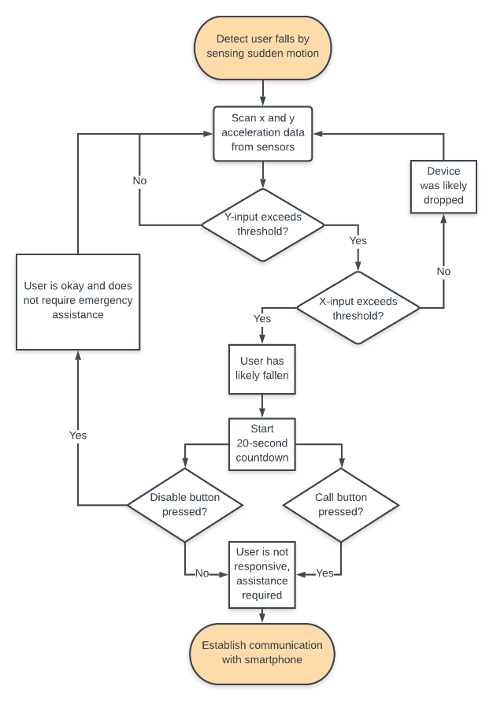

Figure 2: Flowchart used to organize code structure.

If a user falls while equipped with the device, the fall will be detected by sensing sudden motion using the MSA301 accelerometer, meaning that raw data will be constantly scanned from the sensor. If the acceleration values in more than one direction exceed a predefined threshold, obtained from calibration, the device will assume that the user has fallen. Assessing multiple directions simultaneously will prevent false-alarm cases created by unintentionally dropping the device, in which the threshold will likely be exceeded in a single direction. If a fall is suspected, a 20-second countdown will begin which provides the user sufficient time to disarm the device if it is falsely triggered or assistance is otherwise not required. If the countdown expires or the emergency call button is pressed, the device will then communicate a message to a smartphone using the HC05 Bluetooth module.

## Design Concept Selection

The EFDD makes use of many different components and uses them all in unison in order to complete its task of saving someone when they fall. The first and most central sensor is the accelerometer. The device needs an accelerometer so that it can detect when the user has fallen. The two types of accelerometers that were considered for prototype are the 6-axis and 3-axis accelerometer. The 6-axis accelerometer can measure more quantities than the 3-axis accelerometer, such as forces and speed. Despite this, the 3-axis accelerometer was selected for the prototype since the extra features of the 6-axis accelerometer are not needed and only add to the overall cost of the device. Once the accelerometer detects a fall, the EFDD needs to communicate that it is active to the outside world. To accomplish this task a communication system consisting of a buzzer, LCD screen, and Bluetooth module was selected. The buzzer produces a tone when a fall is detected, and this is important since it can notify surrounding people who will be able to help and the user. It is important that the user knows the device is armed in the case a false positive is detected, the user can disarm the EFDD before it notifies contacts. The LCD screen will tell the user what state the device is in, and this allows the user to know if they need to disarm the device, in case of a false fall or if help is not needed. The LCD also acts as a confirmation to let the user know that help has been contacted, so that they are not left uncertain whether the device worked properly or not. The Bluetooth module has the most important job of the communication system, which is notifying the emergency contact. These three components were carefully selected since they most effectively meet the specifications of the communication system. Two buttons were also selected for the device so that the user could input their decisions into the device. Two buttons are optimal for the current design, as it keeps the device simplistic but also allows the user to call for help and disarm the device. Finally, the Arduino was selected as the processing component for the EFDD. The Arduino was selected for its cheap price, simplistic design, ease of use, and its compatibility with other sensors. All the components were carefully selected to work in unison with one another, and to complete specific but crucial tasks.

## Development of Final Design

### Circuit Schematic

The KiCAD design software was used to construct a basic circuit schematic of the physical prototype prior to its assembly, represented by Figure 3. This schematic acts as a blueprint for the wiring of each component to the UNO board and ensures that sufficient I/O data pins are available on the UNO board to support all necessary components concurrently. For simplicity and practicality, schematics representing individual modules such as the UNO board and accelerometer are omitted and are therefore illustrated as blocks labeled with the corresponding part name. Given that the MSA301 accelerometer relies only on the Arduino clock and data pins, 10 of the 14 digital I/O pins on the board are allocated towards the Bluetooth module, the LCD display screen, and 2 buttons.

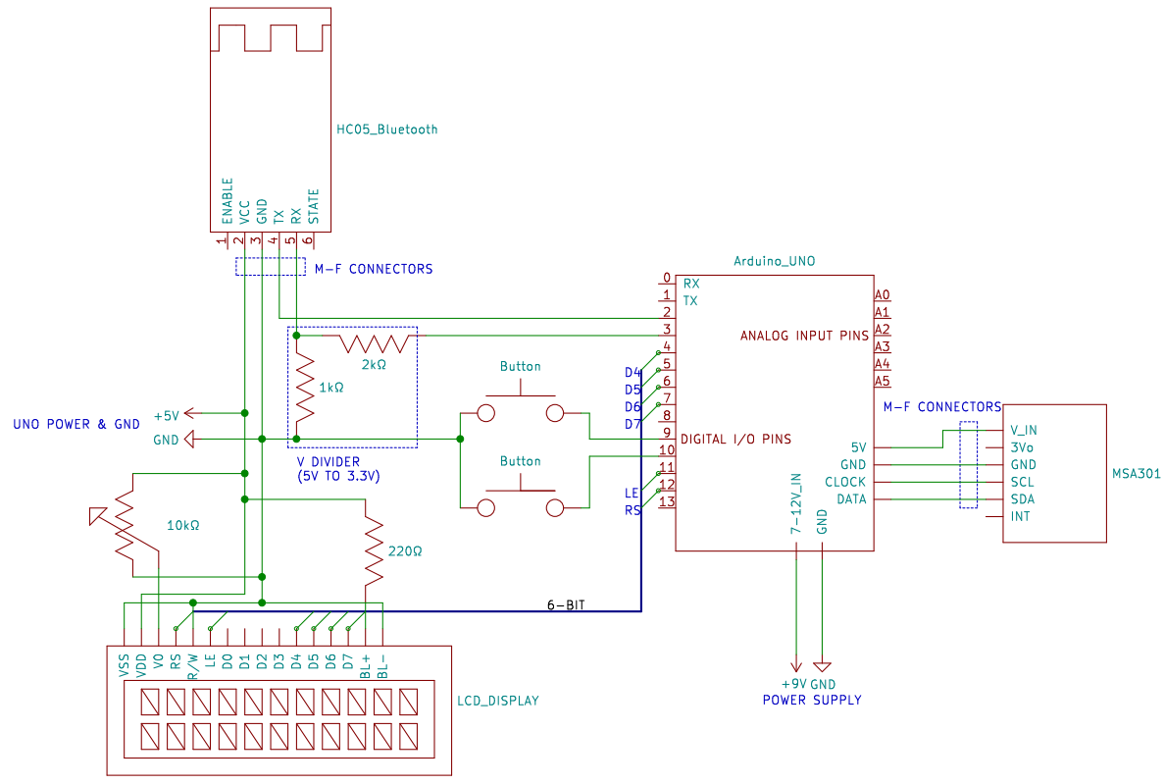

Figure 3: Circuit schematic of the device prototype

Because the RX (data receive) pin on the HC05 Bluetooth module is incompatible with the 5 V provided by the Arduino output pins, a voltage divider is constructed using a 1 kΩ and 2 kΩ resistor. This converts the 5 V voltage supplied by the Arduino into 3.3 V used by the HC05, preventing damage to the device. The 10 kΩ potentiometer is used to finely adjust the contrast of the LCD display, allowing for legibility of its output data. The internal pullup resistance included on the Arduino board is exploited by setting input pullup as the pin mode of the two buttons. For this reason, the buttons are connected from the board directly to ground without the need of any additional resistors. Male-to-female jumper cables will be used to link the HC05 and MSA301 to the Arduino board, which will be powered using a 9 V battery and barrel connector, making the device portable.

### Sensor Calibration and Programming

The fall detection system relies purely on raw input data from the accelerometer to identify a substantial sudden change in motion. Due to the counterintuitive numerical data provided by the sensor, opposed to a standard unit of measurement such as m/s2, a threshold value was obtained through experimentation of the sensor using serial communication from the Arduino to a console. This threshold, representing the data input value at which the countdown is triggered, is derived from numerical readings produced by the serial console when the accelerometer is moved vigorously, simulating the abrupt change in motion resulting from a fall.

Due to the design of the accelerometer, false acceleration readings are produced when the accelerometer is stationary, depending on its orientation. Figure 4 provides a graphical representation of the sensor input data over time when the device is held upright, sideways lengthwise, and sideways widthwise. The x, y, and z axes are represented by blue, red, and green lines respectively.

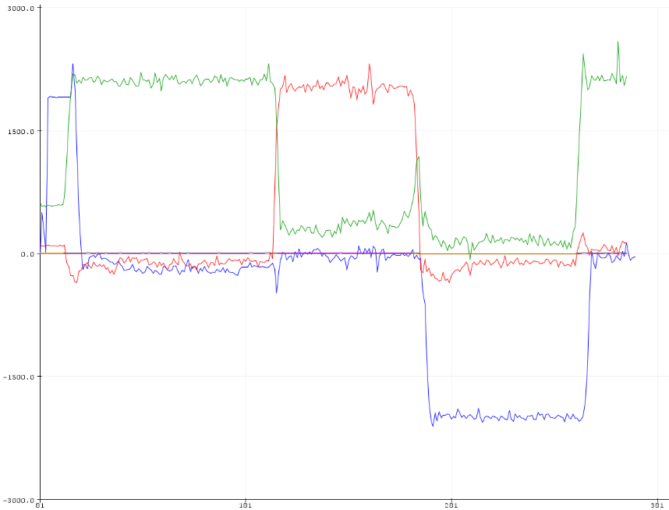

Figure 4: Triaxial readings from the accelerometer when it is held in various positions

Because of this phenomenon, the accelerometer can more accurately detect a sudden change in motion by observing a change in acceleration. This will allow for the transfer of more precise and consistent data readings to the Arduino processor. Change in acceleration can be measured by the MSA301 accelerometer by obtaining two sets of triaxial readings with a time delay in between, and then computing the difference between the readings in the corresponding axes. A screenshot of the Arduino C code for this computation is included in Figure 5.

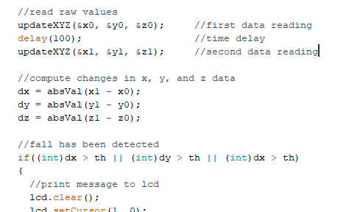

Figure 5: Acceleration change computation pseudocode

The program calculates a change in the triaxial data values using the absolute value of the difference of the first and second data sets, since only the magnitudes are relevant. This process was found to be effective in accurately detecting abrupt movements upon further experimentation of the module. Figure 6 plots the triaxial readings over time after this modification, when the device is initially resting on a table then moved back and forth in all 3 directions, demonstrating that input values remain at zero when the device is stationary.

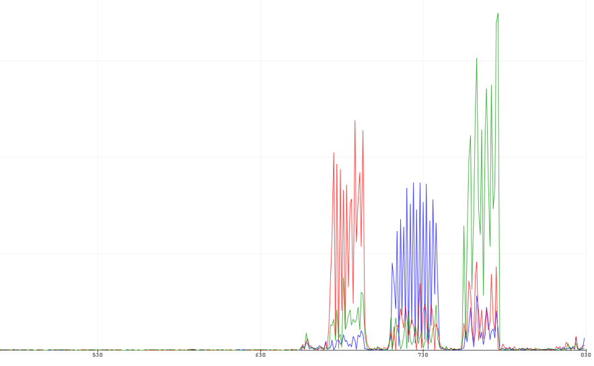

Figure 6: Accelerometer data after code modification

From experimentation, a value of 2000 was selected as the threshold for the fall detection program. Values close to this threshold are produced for any axis when the sensor is forcefully moved by hand. Selecting this value ensures that the countdown is triggered in the event of an actual fall and that the device is not falsely triggered when the user makes slight movements such as walking.

### Prototype

In order to evaluate the functionality of the Arduino program and device circuit connections, a physical prototype was constructed according to the circuit schematic presented in Figure 3. Although the design of the prototype is crude, as breadboards and jumper cables are used to connect components together, the product does achieve the fundamental specifications outlined on page 5. When a sudden change in motion from a user fall is detected by the accelerometer, the buzzer turns on for 1 second, a message is displayed on the LCD screen, and the 20 second countdown begins. A message indicating that the user has fallen and requires assistance is sent to a mobile device connected to the HC05 transceiver when the countdown expires, or the red button is pressed. Otherwise, when the blue button is pressed, the countdown is cancelled, and the system returns to its neutral state. A photograph of the complete prototype is included in Figure 6.

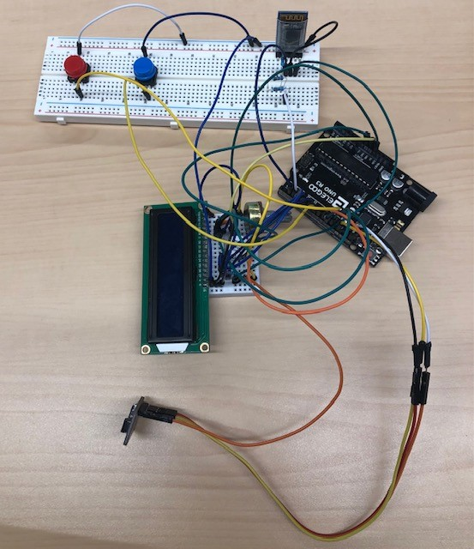

Figure 7: The completed physical prototype

To accurately predict when the user has fallen, the threshold in the main code is compared with the input of each axis individually, and the countdown is activated when more than one axis input is greater than the threshold value. This was achieved by assigning Boolean values to a set of variables corresponding to whether the individual inputs exceed the threshold. The condition for the succeeding if-statement is therefore true when any combination of input values are greater than the threshold. Comparing the input data using this approach aims to reduce false detections triggered by dropping the device, in which case the device moves along a single axis. Figure 7 illustrates the code involved in this process.

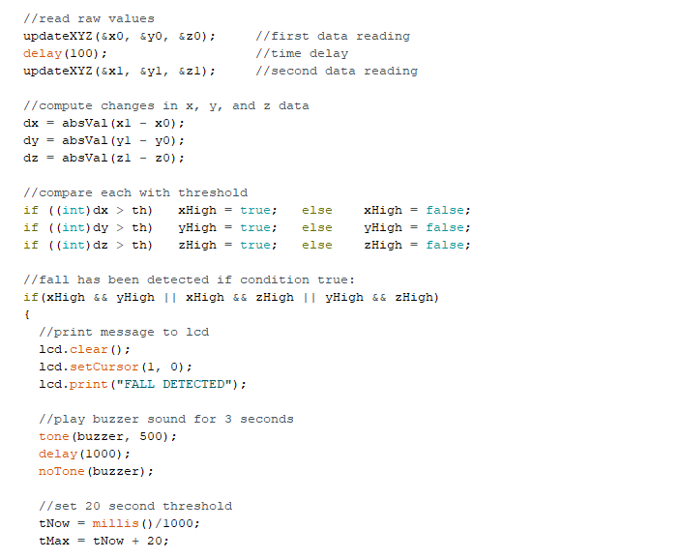

Figure 8: Input data assessment code

In addition to the electronic prototype, a 3D CAD design of a proposed external case for the device was created using SolidWorks. The created assembly is 15 cm in length, with a width of 7 cm and a height of 5 cm. The design is intended to have a clean and straightforward appearance and includes cut-out sections on the front side to expose the 2 buttons, the LCD display, and the buzzer. The external case is designed to contain all electronic components used in the prototype. However, because the model is additionally designed to accompany the breadboards used to simplify the prototype, the overall size of the case is not ideal for portability. Therefore, to make the external case practical, the EFDD would likely require a printed circuit board and soldered connections. This would allow for a more compact configuration of the electronic components, therefore reducing the size of the external casing, making it more portable. Figure 9 contains a screenshot of the external case in SolidWorks with the top face omitted.

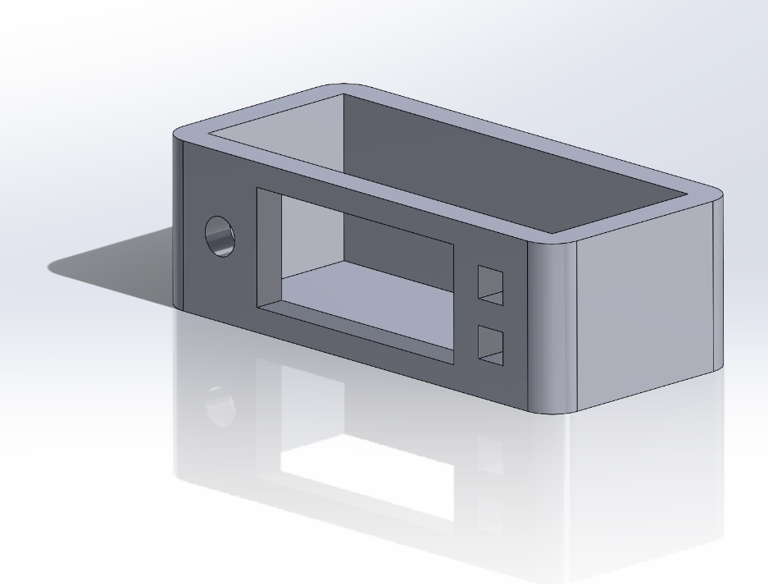

Figure 9: CAD representation of the EFDD case

## Assessment against Project Metrics

The general requirements for this project are that the final design solution includes some type of acceleration sensor, a telecommunication device, and a central processing system. The Emergency Fall Detection Device includes all three of these components. From the beginning of the development cycle, it was determined that the EFDD must detect whether a person has fallen or not, and then notify an emergency contact if needed. The prototype described by the team includes an accelerometer that will constantly measure the acceleration of the device and will detect any noticeable change in acceleration. The two buttons and an LCD screen were used to communicate with the user and determine if additional help was required or not. If the user requests for help, then the Bluetooth module would send a signal to the emergency contact, alerting them of the fall and requesting for their assistance. The EFDD prototype includes all functional specifications set out at the beginning of the project, therefore the EFDD meets all the requirements and is a resounding success.

## Environmental and Social Considerations

The purpose of this project is to ultimately save more lives and prevent people from sustaining more serious injuries from falling. However, this does not mean that other considerations like environmental factors and social concerns can be disregarded. The project was not only designed to be eco-friendly but also to have a positive impact on society. The design is fully detachable, and each component of the design can be reused elsewhere. Having reusable components will save costs for future Arduino related projects, environmental resources to build each module, and CO2 emissions from manufacturing and transferring the modules. In addition, a 3D printer is used to make an exterior case of the EFDD. Using a 3D printer takes 50-100 times more electricity than injection molding machines [12]. Moreover, fumes produced by 3D printing are toxic to the environment on a mass scale. However, a product manufactured by a 3D printer has a significantly less carbon footprint than the same product manufactured in a factory.

The EFDD has great potential to save the lives of many elderlies and those who have disabilities. Furthermore, the EFDD will alleviate the care and supervision required by the user’s family or senior care workers and give the individual more freedom, by lessening the concern of leaving them unsupervised.

## Economic Considerations

For the product to be helpful and save lives it must be easily affordable, but to ensure the success of the product a profit must also be made. Team 12’s goal was to make the cost under $90, and as such the team currently plans to sell the EFDD for $79.99. To build the prototype, it costs $61.62, a breakdown of costs can be seen in Table 1 below. While this number does not take into account to the assembly process, Team 12 still makes $18.38 on every sale giving a 29.82% profit margin, which more than makes up for this cost. Because the target market is the elderly and the disabled, it is imperative that Team 12 follows the triple bottom line and price the product reasonably. The retail price of the EFDD is $79.99, making it relatively inexpensive for a potentially lifesaving device, and still generating a 29.82% profit margin. At this price point it is slightly more expensive than smaller devices that just detect the fall and set off an alarm, and much cheaper than smart watches that can detect a fall. However, the added benefit of Team 12’s device is the ability to notify a person directly, allowing it to be a better option than the competitors. If the parts were to be ordered in bulk, the manufacturing process became streamlined, and the Arduino was replaced with a cheaper more specialized processing device, the cost to produce an EFDD could be drastically reduced and made even more affordable.

A bill of materials for the fall detection project is included in Table 1. This provides a summary of the main components, excluding cables, solder, or casing materials, that are used in the physical prototype, with the associated cost of each. Additionally, the functional purpose and quantity for each part is provided in the adjacent columns.

Table 1: Proposed bill of materials

|  |  |  |  |
| --- | --- | --- | --- |
| **Component** | **Purpose** | **Quantity** | **Cost** |
| 9V Lithium-Ion Battery | Power Supply | 1 | $6.47 |
| Elegoo Uno R3 | Data Processing | 1 | $20.00 |
| HiLetgo HC-05 Wireless Bluetooth RF Transceiver | Communication | 1 | $10.77 |
| Buzzer | Communication | 1 | $0.94 |
| LCD Display | Communication | 1 | $15.00 |
| MSA301 3-axis accelerometer | Sensor | 1 | $8.14 |
| 1825910-6 tactile switch (button) | Sensor | 2 | $0.30 |
| **Total Cost** | | | $61.62 |

## Professionalism, Safety, Regulatory Compliances and Ethics

While designing the Emergency Fall Detection Device (EFDD), the professionalism, safety and regulatory compliances of the design were considered throughout the duration of this project. A professional design also complies with a specific code of ethics that relates to the design or project. With regards to an Emergency Fall Detection Device, it essential that it complies with all regulatory safety standards, especially since people are relying on this device to save someone’s life. According to the Professional Engineers Ontario (PEO) Code of Ethics, professional and practicing engineers have a job to protect society under all circumstances. When designing a device that will be implemented in society, it is essential that this product is safe to use and that all risk mitigation steps have been accounted for to plan for any unexpected circumstances that may occur. While designing the EFDD, Team 12 carefully chose the safest idea for each component of the design. For example, while coding the accelerometer and Bluetooth module, the code was iterated several times, to maximize the speed of the process time so that it performs at top speed. Throughout the design process and development of this device, if a team member ever felt uncertain of the safety or implementation of a specific component, it was their responsibility to address the issue they had. As stated in the PEO, “A practitioner must co-operate in working with other professionals engaged on a project [13].” Team members who testify interest and thoroughly evaluate the safety of the design show that they are self-motivated and determined to design a functional and safe device. To conclude, the Emergency Fall Detection Device is a safe and reliable device and complies with all necessary safety and regulatory compliances.

# Conclusions

The fall detection design project required effective research and communication skills as well as a determined attitude among all members of the group. The team had to work together, learn, and understand how to implement different interactive components on a breadboard, and then code each of these components on the Arduino IDE software system, to successfully come up with a design that solves a real-world problem. The purpose of this project was to address a current problem in society, and develop a technology that includes sensors, a data processing unit and telecommunication device to solve this problem. Team 12 made an emergency fall detection device that is used to alert an emergency contact if it detects a sudden change in acceleration. This design successfully incorporated an accelerometer, Bluetooth module, buttons, LCD screen and a buzzer all on Arduino. The significance of this device is to primarily save those from suffering serious injuries after a bad fall. It was designed to allow the elderly, as well as others who are disabled to walk around independently without the need of constant supervision in case of an emergency. This device will call for emergency assistance within 20 seconds of the fall. The design accounts for all possible scenarios. If the user is okay, there is a disarm button which terminates the program and does not call for emergency assistance. There is also a button that calls for help immediately, if the user is responsive and can press a button. Lastly, the device accounts for the rare chances of the user being unresponsive, and it will automatically call for assistance after 20 seconds of the fall. Overall, this design brings many benefits to society. Having reassurance and knowing that a device will call for emergency assistance if it notices a sudden change in acceleration is why this device is a huge interest for the safety and reassurance of people who need supervision when traveling alone.

# Recommendations

Despite the successful prototype of the EFDD, there is still a lot of room for improvement and adaptation with regards to the device, that were restricted by time and budget limitations. One of these desired improvements is improving the Bluetooth connectivity. The prototype has trouble achieving a stable connection with the emergency contact the user has selected, creating an obvious flaw with the device as unstable connection lowers the chance that the device is able to perform as intended. To create a better connection either the program the Arduino is using needs to be iterated, or a stronger Bluetooth module is needed. Due to the time constraints mentioned above, the exact cause of the poor connection was not discovered, but the team believes it is either the code or the component itself. The EFDD code could also use some more features, adding the ability to send a text message or a phone call automatically when the user's life is potentially in danger could help reach more people and make the device exponentially more effective. Another improvement that can be made is adding a WIFI module, so that the user has a greater number of options in selecting emergency contacts. Additionally, this would extend the effective range of wireless communication to a mobile device, as connection to the current Bluetooth module is unstable when the recipient moves roughly 5 metres away from the device. Further improvements that can be made to the EFDD is a redesign on the case that houses all the components. The casing that was created is an early prototype that leaves much room for improvement. The current case was designed to hold an earlier model of the EFDD, and since the device was iterated and improved, the case is not optimized for the new design. Some ways to improve the case would be to make it smaller and add a clip to the backside, so that it can hooked on to the user’s pants or belt, as was originally intended. The case could also be remodeled to better protect the internal wiring, to ensure it does not break on a fall. Another recommended improvement is printing a specialized PCB board to connect all the modules to the Arduino, such as a custom-designed shield. A printed PCB board removes the need for breadboards and wires, reducing overall material costs and meeting industry standards of similar products. The specialized PCB board will also reduce the size of the overall device, which allows for a smaller case and greater portability. The addition of a memory storage component to the EFDD would also benefit the overall effectiveness of the product. Having memory will allow the user to create multiple emergency contacts, so that when they need help a list of people are notified. If more people are notified, the likelihood of the user getting the assistance they need increase, which makes the device more effective.

# List of References

|  |  |
| --- | --- |
| [1] | "Keep on Your Feet - Preventing Older Adult Falls," Centres for Disease Control and Prevention, 16 December 2020. [Online]. Available: https://www.cdc.gov/injury/features/older-adult-falls/index.html. [Accessed 5 November 2021]. |
| [2] | G. F. Fuller, "Falls in the Elderly," 1 April 2000. [Online]. Available: https://www.aafp.org/afp/2000/0401/p2159.html#afp20000401p2159-b15. [Accessed 5 November 2021]. |
| [3] | S. Ponsford, "What is orthostatic hypotension?," Medical News Today, 29 June 2017. [Online]. Available: https://www.medicalnewstoday.com/articles/318158#Causes. [Accessed 5 November 2021]. |
| [4] | R. Brouhard, "Unconsciousness First Aid and Treatment," Verywellhealth, 6 July 2021. [Online]. Available: https://www.verywellhealth.com/what-is-unconscious-1298695. [Accessed 5 November 2021]. |
| [5] | "Sudden Cardiac Arrest," Cardiosmart, 31 October 2016. [Online]. Available: https://www.cardiosmart.org/topics/sudden-cardiac-arrest. [Accessed 5 November 2021]. |
| [6] | "Personal Emergency Response Systems (PERS)," Keiro, [Online]. Available: https://www.keiro.org/fact-sheet/personal-emergency-response-systems. [Accessed 5 November 2021]. |
| [7] | "What is Fall Detection?," Lively, [Online]. Available: https://www.lively.com/health-and-aging/what-is-fall-detection/. [Accessed 5 November 2021]. |
| [8] | S. M. F. Z. Dharmitha Ajerla, "A Real-Time Patient Monitoring Framework for Fall Detection," 22 September 2019. [Online]. Available: https://www.hindawi.com/journals/wcmc/2019/9507938/. [Accessed 5 November 2021]. |
| [9] | "3 axis accelerometer vs 6 axis gyro: what is the difference?," SAFE LOAD testing techonologies, 16 11 2020. [Online]. Available: https://www.safeloadtesting.com/3-axis-accelerometer-vs-6-axis-gyro-what-is-the-difference/#What_is_a_6_axis_gyroscope. [Accessed 6 11 2021]. |
| [10] | "Arduino Uno Rev3," Arduino store, [Online]. Available: https://store.arduino.cc/products/arduino-uno-rev3. [Accessed 6 11 2021]. |
| [11] | amandaghassaei, "Powering Arduino With a Battery," instructables circuits, [Online]. Available: https://www.instructables.com/Powering-Arduino-with-a-Battery/. [Accessed 6 11 2021]. |
| [12] | J. Flynt, "The Environmental Impact of 3D Printing," 3DINSIDER, 21 2 2017. [Online]. Available: https://3dinsider.com/environmental-impact-3d-printing/. [Accessed 2 12 2021]. |
| [13] | P. E. Ontario, "Code of Ethics," [Online]. Available: https://www.peo.on.ca/licence-holders/code-ethics. |